CNN Based Deep Learning Method for Detecting Breast Cancer

A PROJECT REPORT

Submitted in partial fulfillment of the Requirements for the Award of the Degree of

BACHELOR OF TECHNOLOGY

In

**INFORMATION TECHNOLOGY**

Submitted by:

**Utkarsh ( 2K19/IT/136 )**

**Varun Kumar ( 2K19/IT/140 )**

**Yashit Kumar ( 2K19/IT/149 )**

Under the supervision of

Prof. Kapil Sharma

**DEPARTMENT OF INFORMATION OF TECHNOLOGY**

DELHI TECHNOLOGICAL UNIVERSITY

**(Formerly Delhi College of Engineering) Bawana Road, New Delhi - 110042**

MAY, 2023

DELHI TECHNOLOGICAL UNIVERSITY

(Formerly Delhi College of Engineering) Bawana Road, Delhi-110042

# CANDIDATE’S DECLARATION

We, UTKARSH 2K19/IT/136, VARUN KUMAR 2K19/IT/140, YASHIT KUMAR

2K19/IT/149, students of B.Tech. (Information Technology), hereby declare that the project Dissertation titled **CNN Based Deep Learning Method for Detecting Breast Cancer** which is submitted by us to the Department of Information Technology, Delhi Technological University, Delhi in partial fulfillment of the requirement for the award of the degree of Bachelor of Technology, is original and not copied from any source without proper citation. This work has not previously formed the basis for the award of any Degree, Diploma Associateship, Fellowship or other similar title or recognition.

Place: Delhi

Date: 26 May 2023

Utkarsh Varun Kumar Yashit Kumar

(2K19/IT/136) (2K19/IT/140) (2K19/IT/149)

**INFORMATION TECHNOLOGY**

DELHI TECHNOLOGICAL UNIVERSITY

(Formerly Delhi College of Engineering) Bawana Road, Delhi-110042

# CERTIFICATE

I hereby certify that the Project Dissertation titled **CNN Based Deep Learning Method for Detecting Breast Cancer** which is submitted by UTKARSH 2K19/IT/136, VARUN KUMAR 2K19/IT/140, YASHIT KUMAR 2K19/IT/149, students of B.Tech. (Information Technology), Delhi Technological University, Delhi in partial fulfillment of the requirement for the award of the degree of Bachelor of Technology; is a record of the project work carried out by the students under my supervision. To the best of my knowledge this work has not been submitted in part or full for any Degree or Diploma to this University or elsewhere.

Place: Delhi Prof. Kapil Sharma

Date: 26th May 2023 SUPERVISOR

**ABSTRACT**

Cancer remains one of the deadliest illnesses in the world, with almost 10 million deaths recorded in the last year alone. Breast cancer (BC) accounts for 22.6% of these fatalities, making it one of the worst cancer kinds. In India, breast cancer represents 14.7% of all cancer cases and is the main reason of cancer-related deaths. Despite numerous studies on early breast cancer detection, a significant percentage of cases remain undiagnosed, with only about 86% of cases being identified correctly. Early detection is crucial to facilitate prompt treatment initiation and reduce mortality rates. The risk of incorrect detection in cell biopsy pictures puts a person's life at danger. Easily adaptable new alternative methods for a variety of data sets, are inexpensive, dependable, and safer, and can provide an accurate forecast are urgently needed. Convolutional Neural Networks (CNNs) were proposed in this study for breast cancer identification in order to reduce the costs associated with manual analysis since deep learning techniques are revolutionising the area of medical image analysis. The final authority on cancer diagnosis is with surgical pathologists. In the absence of a tissue diagnosis, the diagnosis of cancer cannot be reliably inferred, regardless of how high the index of clinical suspicion may be. With very few circumstances, definite cancer treatment shouldn't begin before a tissue diagnosis has been made. Most hospitals have policies supporting this practice spelt out in their bylaws, and hospital tissue committees and accrediting organisations keep a close eye on them. Understanding the issue at hand, to determine the likelihood of breast cancer, we propose a classification model using CNN.

DELHI TECHNOLOGICAL UNIVERSITY

(Formerly Delhi College of Engineering) Bawana Road, Delhi-110042

# ACKNOWLEDGEMENT

We would like to express our gratitude and thanks towards our mentor **Prof. Kapil Sharma** for his exemplary guidance, valuable feedback and constant encouragement throughout the duration of the project. He helped us in our project and team engagement activities and provided good insights and advice that will be helpful in developing our skills.

We would also like to thank our colleagues who guided me in our projects. Their perspective criticism kept us working to learn in a much better way. Working with him was an extremely knowledgeable experience for us.

Place: Delhi

Date: 26 May 2023

Utkarsh Varun Kumar Yashit Kumar

(2K19/IT/136) (2K19/IT/140) (2K19/IT/149)

# TABLE OF CONTENTS

|  |  |
| --- | --- |
| **Candidate’s Declaration** | 1 |
| **Certificate** | 2 |
| **Abstract** | 3 |
| **Acknowledgment** | 4 |
| **Contents** | 5 |
| **List of Tables** | 7 |
| **List of Figs**  **List of Symbols** | 8  9 |
| **CHAPTER 1: INTRODUCTION** | 11 |
| 1.1 Overview | 11 |
| 1.2 Early Detection | 11 |
| 1.3 Medical Imaging | 12 |
| 1.4 AI in Breast Cancer Detection | 12 |
| 1.5 Motivation | 13 |
| **CHAPTER 2: LITERATURE REVIEW** | 14 |
| 2.1 Overview | 14 |
| 2.2 Review of the Related Papers | 14 |
| 2.3 Medical Imaging | 17 |
| 2.4 The Value of Medical Image Assessment | 17 |
| 2.5 Medical Image Inspection Using ML Techniques | 17 |
| 2.6 Traditional Machine Learning Classifiers | 18 |

* 1. Deep Learning 18
     1. Neuron 18
     2. Artificial Neural Network 19
     3. Image Processing with Neural Networks 20
     4. Kinds of Neural Networks 21
     5. Convolutional Neural Network 22
  2. Summary 33

CHAPTER 3: PROPOSED METHODOLOGY 34

* 1. Overview 34
  2. Our Working Approach for Breast Cancer Detection 34
     1. Convolutional Layer 34
     2. Batch Normalization Layer 34
     3. Pooling Layer 35
     4. Flatten Layer 35
     5. Fully Connected Layer 35
  3. Summary 36

CHAPTER 4: RESULT AND DISCUSSION 37

* 1. Overview 37
  2. Implementation 37
  3. Result 39

CHAPTER 5: CONCLUSION AND FUTURE WORK 42

5.1 Conclusion 42

REFERENCES 43

LIST OF TABLES

|  |  |
| --- | --- |
| **Table Name** | **Page No.** |
| Table 2.1: Different classification models with their accuracy and methods | 16 |
| Table 4.1 Comparison of performance among previous proposed models | 41 |

**LIST OF FIGURES**

|  |  |
| --- | --- |
| **Figure Name** | **Page No.** |
| Fig 1.1: Cancerous (left) and Healthy (right) Breast Tissue | 13 |
| Fig 2.1: Neuron Structure | 19 |
| Fig 2.2: A simple representation of ANN | 20 |
| Fig 2.3: Simple neural network | 23 |
| Fig 2.4: Convolutional Neural Network | 23 |
| Fig 2.5: Convolutional Operation | 24 |
| Fig 2.6: Convolution Operation of CNN | 26 |
| Fig 2.7: Depth changing from using 32 filter | 27 |
| Fig 2.8: Sliding filter along an input image when the stride is 1 | 27 |
| Fig 2.9: Zero-padding of an input | 28 |
| Fig 2.10: Fully Connected Layer of CNN | 28 |
| Fig 2.11 Before Activation Function (left) and After Activation Function (right) | 29 |
| Fig 2.12: Curve of Sigmoid Function | 30 |

|  |  |
| --- | --- |
| Fig 2.13: Curve of Tanh Function | 30 |
| Fig 2.14: Curve of leaky ReLU Function | 30 |
| Fig 2.15: Curve of ReLU Function | 31 |
| Fig 2.16: (a) Standard Neural Net and (b) After applying dropout | 32 |
| Fig 2.17: Before(left) and After(right) batch normalization | 32 |
| Fig. 4.1. Implementation details of showcased model for breast cancer detection | 38 |
| Fig: 4.2 Confusion matrix of showcased architecture of testing data | 40 |
| Fig. 4.3 Accuracy in training and validation | 40 |
| Fig. 4.4. Loss in training and validation | 40 |

# LIST OF SYMBOLS, ABBREVIATIONS

**Abbreviations:**

**CNN - Convolutional Neural Network**

**ANN - Artificial Neural Network**

**DL – Deep Learning**

**ML - Machine Learning**

**AC – Activation Function**

**AI - Artificial Intelligence**

# CHAPTER 1: INTRODUCTION

* 1. **Overview**

Breast cancer, a prevalent malignancy that commonly affects females, is the second-most frequent reason for mortality in women. Breast cancer has become increasingly common worldwide over time, and each year, more instances are reported. It affects more women than other types of malignancies. If this illness is not identified in a timely manner, it might be fatal [1]. Based on how the cell appears under a microscope, different types of breast cancer are categorised. Invasive ductal carcinoma and ductal carcinoma in situ are the two main types of breast cancer, the latter of which takes time to manifest and often has no effect on patients' day-to-day activities. There are few incidences of the DCIS type (between 20% and 53%), but many instances of the IDC kind., which surrounds the whole breast tissue, is more harmful. This applies to about 80% of breast cancer patients [2].

* 1. **Early Detection**

Early detection increases the likelihood of effective treatment and survival, but its diagnosis takes time and usually necessitates consensus amongst pathologists. Systems for computer-aided diagnosis (CAD) can increase the precision of diagnoses. Lack of early diagnosis forces thousands of women to undergo risky, painful, and scar-causing operations. To address these and similar issues, several studies have been carried out using both conventional machine learning and deep learning-based methodologies. Therefore, having access to reliable screening techniques is crucial for identifying breast cancer's early warning signs. The most common imaging methods used to look for this syndrome are thermography, ultrasonography, and mammography. One of the most crucial techniques for detecting breast cancer early is mammography. Diagnostic sonography procedures like ultrasonography are widely used since mammography is useless for breasts with solid tissue. Given these concerns, thermography may be a more effective method than ultrasonography for identifying tiny malignant tumours, however radiography can prevent microscopic masses [3].

* 1. **Medical Imaging**

Medical imaging and deep learning (DL) techniques will aid in this process. Medical imaging has a substantial impact on clinical illness diagnosis, therapy evaluation, and the identification of anomalies in many biological organs, including the eye [4], lungs [4], brain [5], breast [6], and stomach [7]. Medical image research, which is recognized as a feasible method to get useful information from enormous volumes of data, tries to categorise the organ in question's location, dimensions, and characteristics. Medical imaging includes ultrasound, magnetic resonance imaging (MRI), histology, mammography, and thermography images, is the most reliable method for detecting breast cancer [8].

* 1. **AI in Breast Cancer Detection**

Medical image processing comprises two tasks. The first task, also known as preprocessing, is responsible for feature selection, segmentation, enhancement, and filter application. The second task, also called post-processing, is responsible for classification and/or identification. Several AI approaches have been developed to help doctors in making correct decisions regarding the identification of breast cancer. Both deep learning and conventional machine learning strategies can be used for these

purposes. Manual feature extraction and machine learning algorithms can be used for the extraction of results from images. Manual feature extraction is not needed in deep learning. Deep learning only requires designing an architecture having a proper choice of activation function, number of layers, and in some cases pre-trained models. Machine learning strategies are comparatively faster than deep learning strategies, however, deep learning strategies have achieved superior results in comparison to machine learning strategies. Several deep neural networks have been proposed by researchers in the past for identifying breast cancer. To enable a network to cater to distinctive properties of MR images, the researchers have to state how many layers are to be used, which layer will perform which specific function (pooling, convolutional, batch normalization, etc.), different hyperparameters (number of iterations, kernel size, batch size, etc.) and so on. This makes designing these DNNs labor-intensive and time- consuming. A large amount of time is required to design an optimal network as the decision space is very big.

However, previous NAS methods have limited application since they were unable to find high-performance architectures or were computationally expensive. NAS approaches based on evolutionary algorithms and reinforcement learning are computationally expensive, whereas differentiable NAS approaches have lower performance than architectures designed by humans and are bound to fail on test data even though they perform extremely well on validation data. DNNs have attained high performance in image-based classification problems. DNN models built on 2D convolutional neural networks (CNN) have been employed for the detection of breast cancer

The challenging problems in deep learning (DL), a branch of artificial intelligence and machine learning structure of picture features, has the capacity to learn on its own. A range of recently developed models are used by DL approaches to boost feature extraction from data. Various medical disciplines have employed these variations. Deep learning (DL) employs multilayer neural networks (NNs) to build a hierarchical feature structure from the raw input images. Convolution NNs (CNNs) and stack auto encoders are examples of common deep learning (DL) techniques [9].

# 

# Fig 1.1: Cancerous (left) and Healthy (right) Breast Tissue

* 1. **Motivation**

We chose breast cancer identification and classification, which is a subfield of medical image analysis, after taking into account recent Figs on the fatality rate brought on by breast cancer. Medical picture tumor detection takes time since it relies on human judgment. Pathologists and other specialist medical professionals who are experts in this field evaluate scan images and make recommendations that affect the course of treatment. It takes time to complete this entire process. Because it is going to be performed by devices, computerized analysis of medical images may assist in minimizing the human being's energy, time, and workload in this situation.

**CHAPTER 2: LITERATURE REVIEW**

* 1. **Overview**

Throughout the latest years, many different kinds of research in the area of processing medical pictures have been completed. Image Analysis has attracted researchers from a variety of disciplines, including machine vision, visual analysis, and deep studying. We investigated a few of the research works in hopes of finding the most useful and developed techniques used in recent articles. The dataset we used in our research is from Kaggle and consists of 277,524 images, 78,786 of which have a cancer and 198,738 don't. A Twenty two-layered CNN model has been proposed, which produced excellent results in the diagnosis of breast cancer.

* 1. **Reviews of the related papers**

The efficacy of Ensemble Support Vector Machine (ESVM) in detecting breast cancer was investigated by Wang et al. [10]. Four pre-trained models, including multi-level InceptionV3, ResNet-50, DenseNet-121, and multi-level VGG-16, were employed in conjunction with ESVM, which yielded a maximum classification accuracy of 94.70%. The authors found that their proposed approach outperformed existing state-of-the-art methods. Additionally, to further boost the classification performance, they incorporated an integrated feature mining and voting approach by training their E-SVM classifier.

Li et al. [11] suggested a method for selecting extra Selective patches that combines a deep learning CNN (Convolutional Neural Network) with a clustering ML algorithm. The highest obtained 95% accuracy on the primary test set and 88.89% accuracy on the entire test set using the approach that was projected on four classes that are utilised for the categorization of BC (breast cancer) using photographs. The results are logically related to further state-of-the-art systems' results.

With the use of patients' medical pathology pictures, Sudharshan et al. [12] present a weakly machine learning supervised method and determine the applicability of MIL for a CAD system to identify breast cancer in patients. The BreakHis dataset, which includes histopathology scans from 82 patients, is used for the experiment. They were able to get better outcomes than predicted classification without labelled pictures thanks to multiple instance learning. Their suggested task has a 92% accuracy rate.The initial use of Multiple Instance Learning (MIL) was to predict drug action [13]. Later versions of it, such diversified density (DD), expectation-maximization of the DD function (EM-DD) [14], and MI-support vector machine (MI-SVM) [15], also became well-liked.

Typically, MI-SVM combines the SVM architecture with MI inferencing. Another well-known technique that utilises an ensemble of several weak classifiers in the context of MI is MILBoost [16]. When using histological breast pictures, Roy et al. [17] suggested a PBC (Patch-based classifier) by applying DCNN for the automated diagnosis of cancer. One Patch in One Decision (OPOD) and All Patches in One Decision (APOD) are the two phases of their suggested approach. In their experimental investigation, they found that APOD classification accuracy was 92.5% and OPOD classification accuracy was 84.7%. They were 87% accurate for the ICIAR-2018 concealed dataset

In order to categorise breast tissue as benign or malignant, Gandomkar et al. [18] established a procedure. They then further classified these 2 groups into 4-4 each additional category. Tubular adenoma, Phyllodes tumour, and other benign tumour types. There are four types of malignant cancer: lobular, ductal, papillary, and mucinous. To determine if a patient has breast cancer or not, they employ ResNets, or a deep residual network. For the purpose of early cancer detection, Komura and Ishikawa [19] suggested a method to analyse histopathological pictures with the use of a computer-aided diagnostic system. Their suggested method performs admirably and offers 92.7% accuracy. To exclude the beneficial characteristics from the histopathology pictures, D. M. Vo et al. [20] suggested a DCNN combining the strengths of both weak and strong classifiers.The identification of cancer has then seen better results compared with conventional teaching methods. Instead of using a multinetwork, they extract features using a single network.

|  |  |  |  |  |
| --- | --- | --- | --- | --- |
| **Author** | **Dataset** | **Method** | **Accuracy** | **Remarks** |
| Wang et al. [10] | ICIAR 2018 dataset of medical histopathology pictures | DCNN | 94.70% | Tested Ensemble Support Vector Machine (ESVM) on DCNN using four pretrained models. |
| Li et al. [11] | MRI images | DCNN + Clustering ML | 88.89% | The method was applied to four categories that are used to classify breast cancer using photos. |
| Sudharshan et al. [12] | Histopathology scans from 82 patients | MIL | 92% | Introduced a weakly machine learning supervised approach and evaluated the applicability of MIL for a CAD system to identify breast cancer in patients. |
| Roy et al. [17] | Histological breast pictures | DCNN | 92.50% | One Patch in One Decision (OPOD) and All Patches in One Decision (APOD) were the two phases they suggested for their technique. |
| Gandomkar et al. [18] | Breast histopathology picture | ResNets + Deep residual network | 92.15% | Classified the 2 groups into 4-4 each additional category. Tubular adenoma, Phyllodes tumour, and other benign tumour types. |
| Komura and Ishikawa [19] | Histopathological pictures | CAD | 92.70% | Used to spot cancer in its earliest stages. |

Table 2.1: Different classification models with their accuracy and methods

* 1. **Medical Image**

The examination of human components of the body, cells, or structures for diagnostic purposes, medication, and monitoring of diseases is commonly referred to as medical imaging. Imaging methods include radiography, nuclear medicine, visual imaging, and picture-influenced treatment.

* 1. **The Value of Medical Image Assessment**

Digital processing of images is a trendy and sophisticated method that processes images and videos. Currently, one of the most significant usage of digital image processing is x- ray. Before x-rays, it was highly challenging to look at an individual's bone in the patient's body because the physician had to remove through the flesh and skin of the body to Figure out whether the bone had become fractured or broken. Processing images can be utilized across every viewpoint and path, whether for protection or your use.

Technology for imaging is going to keep improving as time walks by. Nevertheless, the primary objective of platforms nowadays has moved from diagnostic imaging generation and acquiring to picture data additional processing and management. This is motivated by the desire to make more efficient use of the information that presently is available. Current developments in examination research have shown the ability of imaging technology to improve and change numerous facets of medical care medicine.

* 1. **Medical Image Inspection Using Machine Learning Techniques**

Developments in photography and calculating have culminated in an explosive rise in the possible application of artificial intelligence for different diagnostic assignments such as risk estimation, identification, diagnosis, future outcomes, and treatment reaction as well as quick illnesses learning. Algorithms for machine learning (computer methods that "learn" something particular provided particular input information) can use photo- extracted (radio-mic) includes as feedback. The act of radio-mic includes can be combined through a single number, including a cancer signature, which can be connected to the probability of a malignant state, using such artificial intelligence methods. Different methods for machine learning, such as linear discriminant evaluation, vector machines, random forests, decision trees, and neural networks, among others, have been employed over time. Over time, numerous assessments of machine learning algorithms have been published and produced, which include those that function as instructions for fresh scholars entering the field of machine learning.

* 1. **Traditional Machine Learning Classifiers**

A method for categorization is used to assess the model we have suggested. So we finished the first half of the task by creating an algorithm that can identify or categorize the cancer. The model assessment or evaluation of the model that is suggested serves to back up the framework. We utilized six conventional machine learning techniques for our strategy. We utilized those different kinds of classification algorithms to back up our approach. To enhance the precision of our suggested algorithm's cancer identification, we utilized six conventional artificial intelligence classifiers: Naive Bayes, Logistic Regression, Multi-layer Perceptron, K-Nearest Neighbor, Random Forest, and Support Vector Machine.

* 1. **Deep Learning (DP)**

The application of DP is a particular category of artificial intelligence methods that is exceptionally effective at recognizing patterns but necessitates an enormous quantity of information. Deep learning is skilled at identifying objects in pictures since it is carried out employing a minimum of three layers of neural networks that are artificial, with each layer being charged with gathering any number of features from the picture.

* + 1. **Neuron**

Synthetic neurons, which resemble the brain's natural neurons, are the fundamental components of brain networks. These synthetic neurons are dominant mathematical components that receive balanced signals as inputs and execute a function of activation to generate a response message. An artificial neural network's neurons are spread throughout numerous levels. Each neuron has three variables, that are outlined below:

• Weight: Whenever an indication (value) gets received, it becomes multiplied by its weight significance. A neuron alongside a total of three inputs possesses three values for weight that can be modified throughout learning.

• Bias: It is an additional input to neurons that is constantly one, alongside a distinct relationship weight. This guarantees that regardless of whether all the possible inputs are not one (all 0's), the neuron is going to be portrait.

• Activation Function: Functions that activate are additionally referred to as functions of transfer. It aids in the categorization or splitting of data. It utilizes a threshold;

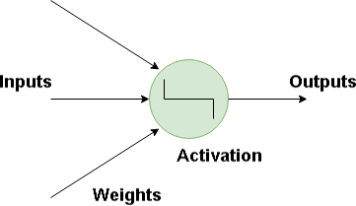according to this limit, we allocate the population at large through multiple groups.

Fig 2.1: Neuron Structure

* + 1. **Artificial Neural Network (ANN)**

The process of DP is a system made up of computational neural networks which have been simulated after systems that exist in the brains of humans. Given that these artificial neural networks function through several layers, this sort of artificial intelligence is referred to as DP.

Neural networks, artificial intelligence are an approach to determining an outcome from a stimulus (a categorization) through the use of weighted links ("synapses") determined employing repeated iterations on information used for training. Every journey using the data used for training updates the number of weights, permitting the neural network's algorithm to generate output that has higher "accuracy." (lower error rate). When carrying out tens of thousands of matrix multiplications, a mixture of storage capacity and velocity is essential. Fig 4.6 illustrates the fundamental artificial brain network:

An artificial neural network typically consists of three distinct levels. The layers are composed of nodes that have connections together. The sections that follow are explanations of each of the three layers of ANN:

* + - * **Input Layer:** The outermost layer is made up of neurons that only obtain feedback as well as pass it on to the afterward layer. The layer that is being input ought to have the identical quantity of layers as the features or attributes that are included in the dataset.
      * **Hidden Layer:** Depending on the kind of approach, there have been concealed layers among the layers of input and output. A great deal of the neurons have been

discovered in the layers that are concealed. before enacting inputs to the subsequent layer, neurons in the layer that is concealed change them. As the neural network develops, its weights are modified to render it more appearance. The information gets processed in the layer that is concealed by an arrangement of weighted relationships. The resultant layer has connections to the layers that are concealed.

* + - * **Output Layer:** The anticipated characteristic or class in a problem with categorization is the outcome layer, and this is established by the kind of models built. The data that is passed from the layer that is hidden is utilized by the layer that produces output for producing results.

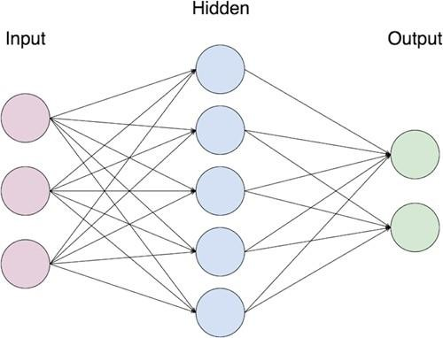

Fig 2.2: A simple representation of ANN

ANN's internal framework may shift itself according to the data that is that goes through it. The following can be achieved using weight modification. Each of the neuronal

network relationships has an amount of weight that manages the electrical signal among both neurons. If the result is good, no modifications need to be made; nevertheless, if the results are inadequate the equipment adjusts by altering the amount of weight to enhance the output. The algorithm examines the final product's accomplishment by juxtaposing it with the unique output offered beforehand in the instructional mode.

## Image Processing with Neural Networks

Although artificial neural networks may be employed to acknowledge or identify object classifications, recognizing an object needs additional effort. A conventional artificial

neural network requires an array of distinctive characteristics gathered from every picture as feedback. Deep deep neural network networks (DNN) function on pixels in images. A matrix may be used to represent a picture, with every component with color knowledge associated with a pixel. The set of values is introduced into the network of neural networks as input information. The relatively small measurements of the pictures, and enable quick and simple learning, finding out the dimension of the vector and the total amount of input vector data. The method of transfer implemented is additionally referred to as a function of activation. Processing images alongside an artificial neural network involves multiple phases, such as:

* + - * **Image pre-processing:** It is a functioning that demonstrates a graphic with identical measurements as the initial picture (contrast improvement, sound reduction). The objective of pre-processing pictures with ANN is to advance, recovery, or restore pictures.
      * **Feature extraction and Data reduction:** It postulate obtaining an assortment of characteristics that are less in number compared to he overall amount of pixele in the window's source area. The procedure kicks off by reducing the image before extracting geometrical elements such as corners, edges, joints, and features of the face, as well as furthermore.
      * **Segmentation:** The splitting of a picture into numerous important areas is referred to by the term segmentation.
      * **Recognition:** It entails identifying the presence and categorization of items in a picture.

Artificial neural networks are used to effectively address categorization, recognition, authorization, testing, improvement, and closeness problems in the processing of pictures.

* + 1. **Kinds of Neural Networks (NN)**

There are various types of NN are artificial. The networks in question are put into effect employing mathematical procedures and an array of variables that determine their result. A few of the more widely recognized ANN are:

* + - * **Radial Basis Function Neural Network (RBF):** It adopts into consideration the points separate from the center. the level of RBF operations is separated into two sections: the base layer, whre the characteristics are merged with the RBF, and the layer closest to the outside, which functions as a form of storage, where the outcome of those features is able to be utilised seriously when establishing the

same manufacturing process in the following time-step.

* + - * **Recurrent Neural Network**: The neural network's recurrent loop operates on the premise of conserving a layer's output as well as consumption it right back to the input to anticipate the layer's outcome. The following are additionally referred to by the term short-term or long-term memory.
      * **Feedforward Neural Network:** This kind of NN is one of the more basic types of artificial neural networks alongside information or feedback traversing in just one course. The information travels through the data input of the nodes before reaching the resulting nodes. The neural network in question can or can not include layers that are concealed. In a nutshell, it has a front-promoted wave and no rear transmission when employing a categorizing activation feature.
      * **Modular Neural Network:** These networks are constructed up of different networks that function on their own while contributing to production. Each neural network system possesses a distinct set of inputs while contrasted with other neural networks which build and carry out separate tasks. To carry out their duties, these networks of computers are unable to communicate or interact with each other.
      * **Convolutional Neural Network (CNN):** CNN have similarities to feeding looking forward artificial neural networks in which the neurons' biases and weights can be acquired.
    1. **Convolutional Neural Network (CNN)**

Kunihiko Fukushima pioneered the notion of CNN in the course of the 1980s. CNN (ConvNets) have been a specific type of brain network that has been established to have been highly efficient for applications that include recognition of images and grouping. Convolutional neural network networks monopolize methods for computer vision for the reason of their precision in identifying images.

ConvNet frameworks specifically presume that all inputs are pictures, permitting us to put particular characteristics into the design. This renders the forwarding function easier to set up and minimizes the total amount of factors in the network's configuration substantially.

Based on unprocessed picture pixels on one side to classification evaluations on the other, every network element still indicates only one distinguishable achieve its purpose. They additionally feature a detrimental operate on the very last layer.

1. **Why CNN differs from an ordinary NN:** CNN systems are distinct from consistent NN due to their construction. Standard neural networks transformation a signal by placing it using an array of layers that are concealed. Each layer is formed of a bundle of cells, with each of them linked to all neurons within the layer that came beforehand it, and all brain cells in each layer operating entirely autonomously with no connections. Lastly, there is an ultimate picture-connected layer by layer that acts as the result layer, corresponding to the forecasts. Standard neural networks fail to adapt effectively for full- image depictions.

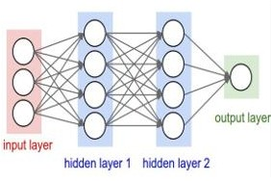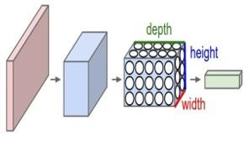

Fig 2.3: Simple neural network Fig 2.4: Convolutional Neural Network

On the opposite side, Fig 2.3 depicts a typical 3-layer network of neuron structure. On the other hand, the rightmost part of the authority work depicts a CNN that organizes its nerve cells into three distinct planes. (width, height, depth).

Each of the layers of a CNN transforms a three-dimensional volume of input to the three- dimensional volume of output of neuron stimulation. In this instance, the red color of the layer that inputs data maintains the picture, so the height and width have the dimensions of the picture, as well as the depth of it, is three. (Red, Green, and Blue channels).

1. **Convolutional Operation:** Convolutional neural networks are networks that transport toward a computation called convolutions. The process of convolution is a computation that generates a third operate through the combination of both functions (f and g). f*g symbolizes the convolution operation of f and g. It can be described as the result of two roles that were changed and moved. This kind of transformation is an instance of essential change.
   * **Input image:** It is provided as a form of feedback.

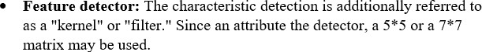

* + 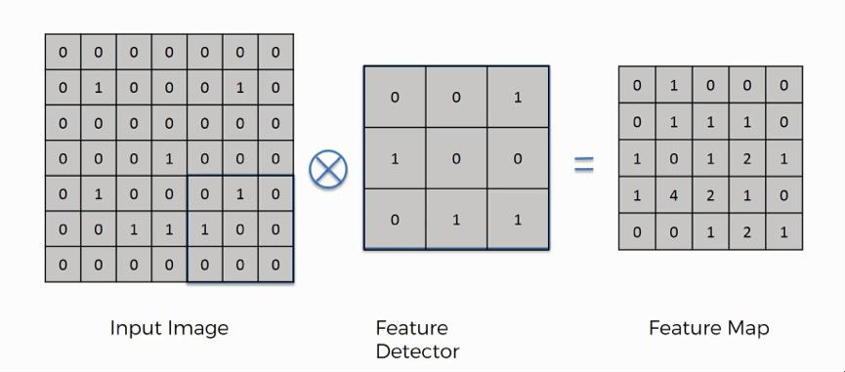**Feature map:** An activation map is a different title from an attribute map. It is referred to as a map of attributes since it is a visualization of which a particular kind of characteristic can be identified within a picture.

Fig 2.5: Convolutional Operation

1. **The Arithmetic of Convolution:** The information presented here demonstrates how the characteristics of the image that is output vary compared to the one that was input because of multiple variables.

Input signal dimension: N Kernel dimension: K

Output feature map dimension: M

The formula for the arithmetic of convolution is as follows:

𝑀 = 𝑁 − 𝐾 + 2𝑃)/𝑆 + 1 (2.4)

where:

N is the size of the input signal. K is the size of the kernel.

P is the amount of zero-padding applied to the input signal (if any). P = 0 means no padding.

S is the stride, which determines the amount of shift applied to the kernel for each step.

* **Forward Pass for Convolutional Layer:** A filter in the pass to the forward of a layer of convolution executes dot multiplication alongside every component of the matrix being input among following another regardless of filter dimensions, then adds every component of one dot product as well as adds a bias value to it. Finally, it puts the resultant value in the appropriate spot of the matrix of outputs corresponding to the dot product. This procedure is carried out throughout the

whole input picture including all filtration systems, alongside an outcome corresponding to every filter.

* **Back-propagation for Convlutional Layer:** It initially establishes the price operation, and subsequently determines how much it moves alongside the result that is obtained. The preceding layer's filter worth will be current after using the gradient descent method in the aforementioned operation. This procedure keeps happening as long as an input layer has been reached.

1. **Layers are used to construct a CNN model:** A straightforward CNN is an array of layers, and every single layer of a CNN utilizes an identifiable function to switch from one volume of triggers to a different one. The three primary kinds of layers used for building CNN frameworks are outlined below:
   * **Convolutional Layer:** This layer forms the fundamental building block of CNN. It possesses certain distinctive features. It addresses a great deal of difficult mathematical tasks. This CONV layer's factors are composed of an assortment of accessible filters. Each filter is modest when measured (in conjunction with

dimensions), nevertheless, it encompasses every possible length of the original input volume.

A typical 3X3 filter on a ConvNet's initial layer, for instance, could measure 5*5*3. Every filter is compressed throughout the movement in the right direction across both the length and width of the original quantity, and the dots are determined at any point throughout the filter's transactions and the input data. Since the filter elements slide throughout the length and width of the source volume, a picture-dimensional stimulation map develops, demonstrating the filter's outcomes at every geographic position. Naturally, the algorithm will develop filters that turn on whenever it detects an apparent characteristic, for instance, a border of a particular direction. These stimulation maps are arranged together in the dimension of depth to generate the resultant volume.

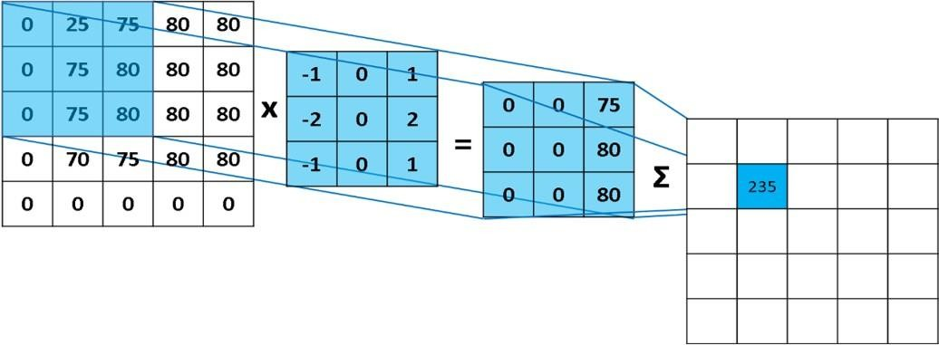

Fig 2.6: Convolution Operation of CNN

* + - **Local Connectivity:** Local connectivity refers to the idea that every single neural network is linked to a portion of the picture being input.
    - **Parameter Sharing:** The collective use of the weights by every neuron in an individual feature map is commonly referred to as parameter sharing.

These attributes bring a decrease in the total amount of variables in the system as a whole, ensuring estimation is more effective.

The dimension of the convolutional layer's quantity of output can be adjusted by all three hyper-parameters. These are the constraints:

* + - **Depth:** The total amount of hue streams in the source picture is expressed by the dimension of the source volume in the initial layer. If the source picture is a hue image, the depth is three members, corresponding to the red, green, and blue paths. The depth is one if the picture is black and white or grayscale format.

The amount of filters employed for the source sound establishes the depth of the resultant volume.

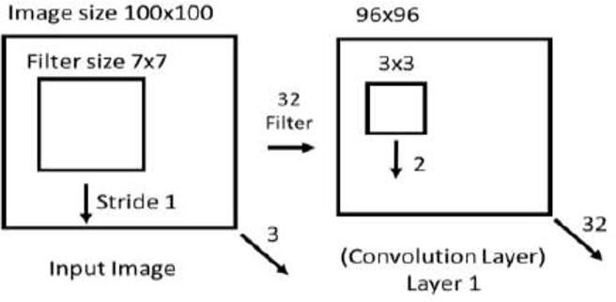

Fig 2.7: Depth changing from using 32 filter

* 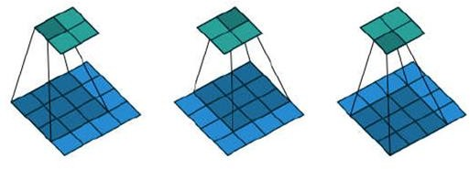**Stride:** This is employed for dragging the pointer together the length and width of the picture being inputted. Whenever the stride is one, filters are shifted to a single pixel at each step. When stride has been conFigd to two, the filters will shift by two pixels at once as we proceed these individuals around. While the stride is one, a 2*2 filter advances together a source dimension of 4*4 through its height and width as illustrated in Fig 4.11.

Fig 2.8: Sliding filter along an input image when the stride is 1

**Zero Padding:** We occasionally cushion the source picture with nothing in the layer that we are entering, and this is referred to as zero-padding. We may regulate the dimension of the data layer through the use of 0 padding. When we refrain from employing 0 paddings, a portion of the edge belongings could get lost.

Fig 4.12 depicts a 0 padding a situation for a parameter.

* **Pooling Layer:** Another component of CNN is the pooling layer. It is commonly positioned following the convolutional layer. The Pooling Layer functions on its own on every one-depth slice of the input and geographically resizes it. The depth size of the feedback volume is uninfluenced by pooling. Its operation is to progressively minimize the geographic dimensions of the illustration in sequence to minimize the

number of variables and calculations in the system, and consequently to regulate overfitting.

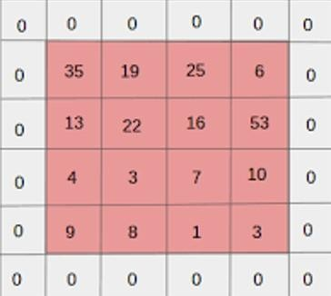

Fig 2.9: Zero-padding of an input

Pooling is accomplished by bringing together the areas of the feedback using techniques that mean implementing the median, highest, or lowest value of the areas only.

* **Fully-Connected Layer (FC):** Every node(neuron) in the FC layer is connected to the node(neuron) in the previous layer, equivalent to a network of neurons. Its stimulation is determined as well by the multiplication of the matrix alongside the amount of weight then subjected to bias, similar to a network of neurons. Usually, an entirely linked layer is an array vector.

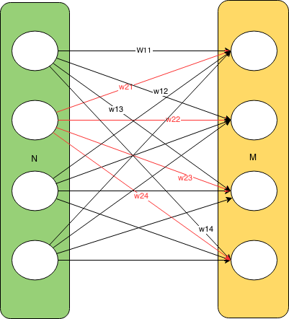

Fig 2.10: Fully Connected Layer of CNN

1. **Activation Function:** The nonlinear nature is incorporated through neural networks by employing activation functions. It shrinks the numbers to a more limited range. A sigmoid activation function, for instance, reduces values between zero and one.

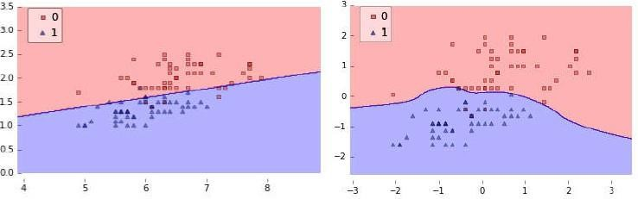

Fig 2.11 Before Activation Function (left) and After Activation Function (right)

Fig 3.10 depicts significance of the ReLU(activation) procedure. The representation on the other hand depicts a situation in which a logistic regression model is used with no use of an activation mechanism, whereas the image on the opposite side depicts an identical situation in which a function that activates is used.

* + **Commonly Used Activation Functions:** In the field of deep acquiring businesses, numerous activation functions are employed. In the following paragraphs, we are going to go over a few prevalent activation functions in brief.
* **Sigmoid:** The Sigmoid function limits the value that is entered to an interval of zero to one. It comes back to one for massive numbers that are positive as well as zero for big negative numbers. The sigmoid function can be written down as**:**

(𝑥) = 1 / (1 + 𝑒^(−𝑥)) (2.6)

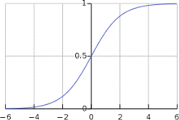

Fig 2.12: Curve of Sigmoid Function

* 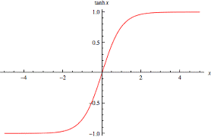**Hyperbolic Tangent/ Tanh:** This property is analogous to the sigmoid function. It limits every natural number to the range of [-1, 1]. The hyperbolic tangent function is mainly applied to difer between two categories.

Fig 2.13: Curve of Tanh Function

* **Leaky ReLU:** It is a better version of ReLU. It resolves ReLU's Death issues. It operates identically to ReLU for positive numbers, but with those that are negative, the value is augmented by an extremely tiny amount.

(𝑥) = 𝑚(𝑎𝑥, 𝑥) (2.7)

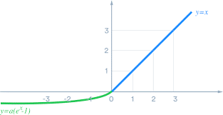

Fig 2.14: Curve of leaky ReLU Function

* **Rectified Linear Unit (ReLU):** It just sets the supplied value to 0 as a limit. It comes back to a value of 1 for values that are positive and zero for values that are negative. Following employing ReLU as a function of activation in AlexNet construction, it was six times quicker than employing the tanh function. The ReLu formula is as outlined below:

(𝑥) = 𝑚(0, 𝑥) (3.8)

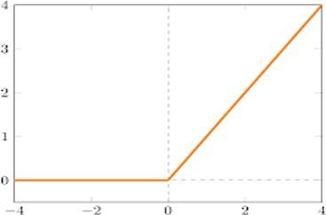

Fig 2.15: Curve of ReLU Function

1. **Regularization Function:** The process of regularization is an approach employed in artificial intelligence for avoiding excessive fitting. By incorporating an expense to a missing operation, regularization decreases excessive fitting. With such a cost, the algorithm undergoes training without acquiring an interconnected collection of characteristic weights.

A straightforward model could fail due to poor generalizing, whereas a model with many variables might fall short because of excessive fitting. In this instance, regularization supports the identification of the framework's selected level of detail.

* + **Dropout:** Dropout is a regularization technique for neuronal networks which helps to decrease interconnected developing between neurons. A dropout necessitates the neural network to acquire stronger characteristics that can be employed in combination with an assortment of different subsets of the neurons that remain.

Dropout momentarily eliminates certain neurons throughout a forward pass. In this example, if we set abandonment to twenty percent, just one of five neurons will be removed throughout the move forward. The weight changes aren't going to be implemented to these particular neurons throughout the backward motion.

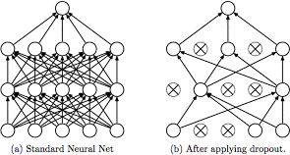

Fig 2.16: (a) Standard Neural Net and (b) After applying dropout

* + **Batch Normalization:** Batch normalization is an approach that decreases within covariate data, and changes in neural networks while which permits the application of greater training costs. In principle, the approach provides a further phase across the various layers whereby the final result of the previous one is standardized. BN additionally stops smaller modifications to the settings from amplifying, resulting in greater learning rates as well as a more rapid network.

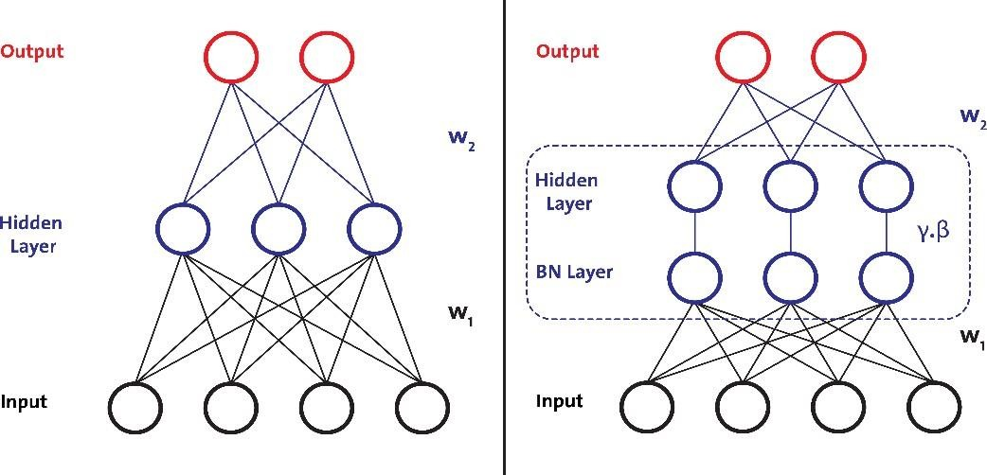

Fig 2.17: Before(left) and After(right) batch normalization

1. **CNNs Hyperparameter:** We used different kinds of hyper-parameter in the model we suggested. A brief explanation regarding the hyper-parameter comes next.
   * **Bias:** Bias has become a mistake resulting from erroneous presumptions within the training algorithm. A method with an elevated bias could overlook pertinent connections between characteristics and focus outputs. (under-fitting).
   * **Learning rate:** The rate of training or step dimension is a hyper-parameter that determines the extent to which newly gathered data surpasses old information.
   * **Epsilon:** It is an extremely tiny amount to avoid splitting by 0 during implementation.
   * **Amsgrad:** AMSGrad employs the greatest number of before-squared slopes to enable very seldom-occurring mini-batches that have big and instructive slopes to have a bigger impact on the whole orientation, and these would have been reduced by rapid calculating in plain Adam.
   * **Epoch:** The number of both front and backward travels of every training instance is referred to as the epoch.
   * **Batch Size:** The number of practice illustrations contained in a single forward or reverse travel by.
2. **Limitations of CNN:** CNNs can only detect picture spatial structures in information. ConvNets aren't as advantageous if the information can't be changed into a picture. In addition, CNNs execute inadequately as soon as it comes to storing various renditions of present and introductions throughout their own. CNNs fail to consider their orientation or environment into consideration.
   1. **Summary**

This section encompasses an overview of every subject associated with our dissertation work, in addition to the working process, benefits, and drawbacks, as well as so on. initially tried to explain the subject matter related to fundamental picture processing, then proceeded to an explanation of the basic CNN framework as well as its many various aggressive parameters.

# CHAPTER 3: PROPOSED METHODOLOGY

* 1. **Overview**

A deep convolutional neural network has been put forth to identify breast cancer in Histopathology images. We will introduce the suggested model and go into great detail on each layer involved in using CNN to detect breast cancer detection.

* 1. **Our Working Approach for Breast Cancer Detection**

In the field of medical image processing, convolutional neural networks are frequently employed. Many scientists have worked on developing a model that can more effectively detect cancer throughout the years. It belongs to a class of deep neural networks used for visual imagery interpretation. Although a fully connected neural network is capable of detecting the cancer, our model uses a convolutional neural network (CNN) due to parameter sharing and connection sparsity.

To detect cancer, a Twenty-two layer convolutional neural network is shown and used. The collected model produces the most effective results for cancer detection. Along with the input and output layers, the hidden layers consist of five convolutional layers, six batch normalization layers, two pooling layers, one flatten layer, five dense layers and three dropout layers.

## Convolutional Layer

The foundational component of a CNN model is a convolutional layer. We have used three convolutional layers in our model. It is used as the first layer to create an input shape for the histopathology pictures that is 50*50*3, bringing all the images into the same dimension. Utilized as an activation function is the Rectified Linear Unit (ReLU). Another convolutional layer with 32 convolutional filters, each measuring 3*3 and using the ReLU activation function is added. Third and fourth convolutional layer having 64 convolutional filters, having the same size 3*3 and ReLU activation function. Finally, Fifth convolutional layer having 128 convolutional filters, again having the same size 3*3 and ReLU activation function is added to the model Thus, in this manner, we have added five convolutional layers to our proposed model.

## Batch Normalization Layer

Batch normalization is an approach that decreases within covariate data, and changes in neural networks while which permits the application of greater training costs. In principle, the approach provides a further phase across the various layers whereby the final result of the previous one is standardized. BN additionally stops smaller modifications to the settings from amplifying, resulting in greater learning rates as well as a more rapid network. Two types of algorithms are employed in batch normalization (BN). The

initial algorithm transforms the initial input of layer x into a moved and normalized value

y. The second method is used for learning a batch-normalized system in its entirety. For these reasons, we have used 6 batch normalization layers in our model.

## Pooling Layer

The primary goal of the pooling layer is to gradually shrink the representation's spatial size to minimize the number of parameters and computing labor required in the network. By scaling down the parameters, it can prevent overfitting. The contamination of over- fitting can be costly when working with breast histopathology images, and the Pooling layer is ideal for this perception. Therefore, for the suggested model, we used three Pooling layers in our model. Pooling layers are of two types – The average pooling layer and the Max pooling layer. We have used two max pooling layers in our proposed model.

## Flatten Layer

A pooled feature map is produced after the pooling layer. After pooling, the flattened layer is one of the most important layers since processing requires that we convert the entire input picture matrix into a single-column vector . After that, the Neural Network receives it for processing.

## Fully Connected Layer

The dense layer was represented by five fully connected layers. The produced vector serves as an input for this layer when the dense function is employed in Keras to process the neural network. The first dense layer contains 512 nodes. We maintained the number of dimensions or nodes as low as possible because they are inversely related to the computer resources we require to fit our model. ReLU has a better convergence performance, hence it is employed as the activation function. The second dense layer contains 128 nodes with ReLU as an activation function. The third dense layer contains 64 nodes again with ReLU as an activation function.

In a nutshell, we have built a cancer-detecting model using a twenty-two layer CNN model. The input dataset must first be loaded, and each image in the input image should have the same size.

The final dense layer's activation function is the SoftMax function. We constructed the model and determined the precision of cancer detection using the Adam optimizer and binary cross-entropy as a loss function.

* 1. **Summary**

The proposed methodology for segmenting and detecting breast cancer is explained in this chapter. With the help of an appropriate diagram and description, segmentation of the cancer tissues and detection utilizing a convolutional neural network are presented.

# CHAPTER 4: RESULT AND DISCUSSION

* 1. **Overview**

We will thoroughly outline the results of our suggested model in this section. We have used Deep Convolutional Neural Network to detect the cancer. We have implemented our model in Python programming language and used Jupyter Notebook which is well known for the dynamic coding environment it provides. Various Python libraries including OpenCV, numpy and scikit learn have been used. TensorFlow and Keras provide the necessary framework to implement CNN. We have acquired the dataset from Kaggle. As of now, we have used accuracy as a performance metric to compare results with other works. Accuracy is obtained by dividing the number of correctly predicted photos by the total number of images.

* 1. **Implementation**

A 2D Deep CNN architecture is showcased in this study for identifying breast cancer. This study made use of the Breast Histopathology Images collection. This dataset includes 277,524 images in which breast cancer was present in 78,786 images and breast cancer was not present in the remaining 198,738 images. On Kaggle, this dataset is accessible to everyone. This dataset comprises of images in jpeg format. All images have same sizes 50 x 50. After dividing the dataset into testing and training data, normalization is applied on both categories. As explained in the previous sections, CNN is a well-defined strategy in medical image processing field. A far better variant of the fundamental CNN architecture is showcased in this study.

A twenty two layer CNN architecture has been proposed by us, which gave outstanding results in identifying breast cancer. The diagram represented in Fig. 1 gives a brief description regarding how our proposed model has been implemented. We have first created a convolutional layer comprising of 32 convolutional filters, each having dimension 3*3, This first convolutional acts as input layer for the showcased model. The ReLU function is selected as activation function for this layer. If the input value is positive, ReLU function will output value same as input value, else it outputs zero. Batch Normalization layer is applied after this convolutional layer. Batch Normalization is an approach through which neural networks are created quickly and additional stability is added by normalization of layers’ inputs. Another convolutional layer comprising 32 filters, each having dimension 3*3 is added. Next, a max pooling layer is added, in which a 2D filter is slid over every channel of feature map. This helps in encapsulating fundamental characteristics of the area covered by filter. Also, the pooling layer diminishes the output shape, which in turn narrows down the number of parameters in the model defined. Since pooling layer encapsulates features, the additional computations will be performed on those encapsulated features instead of accurately determined features presented by the convolutional layer. The most critical characteristics of the input feature map will be the output of max pooling layer. The max pooling layer is followed by another batch normalization layer which is further followed by a dropout layer with dropout ratio 0.3. Next, a convolutional layer that consists of 64 convolutional filters, each with a size of 3*3, using ReLU as the activation function. The second convolutional layer is coupled to a further batch normalization layer which is further followed by a max pooling layer and dropout layer similar to the previous ones. Another convolutional layer consisting of 128 convolutional filters each having dimensions 3*3 with activation function selected as ReLU is added next to the max pooling layer. A flatten layer is then added to flatten the 3D feature map obtained after performing convolutional, pooling and batch normalization functions on our input image, into a 1D dense layer. Five dense layers have been added in the showcased deep CNN architecture. The initial dense layer encompasses 128 neurons with activation function set to ReLU function. 64 neurons make up the second dense layer. The third dense layer encompasses 64 neurons with activation function again set to ReLU function. A dropout layer is attached after the third dense layer with dropout ratio 0.3. This is done to reduce overfitting in our proposed CNN architecture. The fourth dense layer encompasses 24 neurons with activation function again set to ReLU function. The last dense layer contains 2 neurons which give the final output as to whether the image contains breast cancer or not. The activation function in this dense layer is set to the Softmax function. Then the model is trained for 40 epochs with the Adam optimizer and loss as binary cross entropy as we are classifying binary inputs and learning rate of 0.0001.

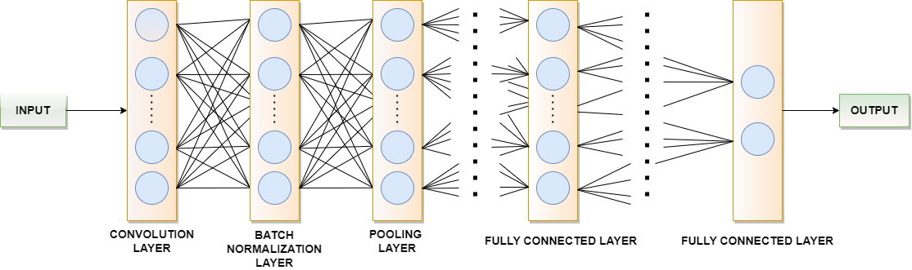

Fig. 4.1. Implementation details of showcased model for breast cancer detection

The evaluation metrics used in evaluating the showcased CNN model for identifying breast cancer are accuracy, precision, recall, and f1 score.

* + 1. **Accuracy**- The accuracy metric describes the number of correct predictions. It is calculated by

*Accuracy* = 𝑇𝑟𝑢𝑒 𝑃𝑜𝑠𝑖𝑡𝑖𝑣𝑒 + 𝑇𝑟𝑢𝑒 𝑁𝑒𝑔𝑎𝑡𝑖𝑣𝑒

𝑇𝑟𝑢𝑒 𝑃𝑜𝑠𝑖𝑡𝑣𝑒 + 𝐹𝑎𝑙𝑠𝑒 𝑃𝑜𝑠𝑖𝑡𝑖𝑣𝑒 +𝐹𝑎𝑙𝑠𝑒 𝑁𝑒𝑔𝑎𝑡𝑖𝑣𝑒 + 𝑇𝑟𝑢𝑒 𝑁𝑒𝑔𝑎𝑡𝑖𝑣𝑒

…(4.1)

* + 1. **Precision**- The precision metric describes the accuracy with which positive class values are predicted by the proposed model. It is obtained by

*Precision* = 𝑇𝑟𝑢𝑒 𝑃𝑜𝑠𝑖𝑡𝑖𝑣𝑒

𝑇𝑟𝑢𝑒 𝑃𝑜𝑠𝑖𝑡𝑖𝑣𝑒 +𝐹𝑎𝑙𝑠𝑒 𝑃𝑜𝑠𝑖𝑡𝑖𝑣𝑒

…(4.2)

* + 1. **Recall**- The recall metric measures the ability of the proposed model’s capability to identify positive samples. It is achieved by

*Recall =* 𝑇𝑟𝑢𝑒 𝑃𝑜𝑠𝑖𝑡𝑣𝑒

T𝑟𝑢𝑒 𝑃𝑜𝑠𝑖𝑡𝑖𝑣𝑒 + 𝐹𝑎𝑙𝑠𝑒 𝑁𝑒𝑔𝑎𝑡𝑖𝑣𝑒

…(4.3)

* + 1. **F1-score**- This metric uses both recall and precision scores of the proposed model and calculates the number of times the model made correct predictions through the entire dataset. It is calculated as follows,



…(4.4)

* 1. **Result**

A confusion matrix represented in Fig. 4.2 is created for analysing the showcased model on the chosen dataset. The showcased model attained a 81.76% recall, 94.86% accuracy, 82.71% F1 score, 83.70% precision.

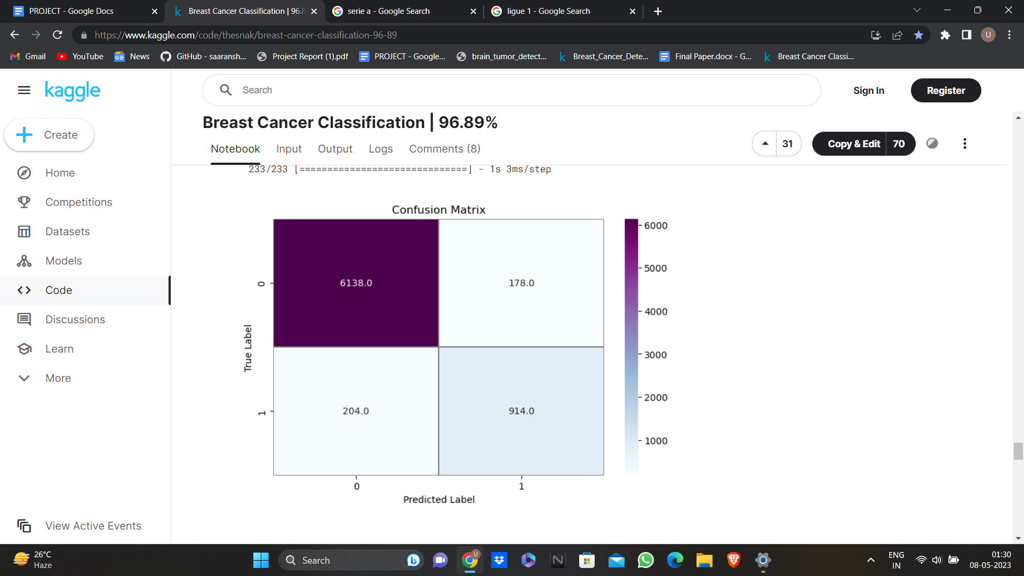

Fig: 4.2 Confusion matrix of showcased architecture of testing data

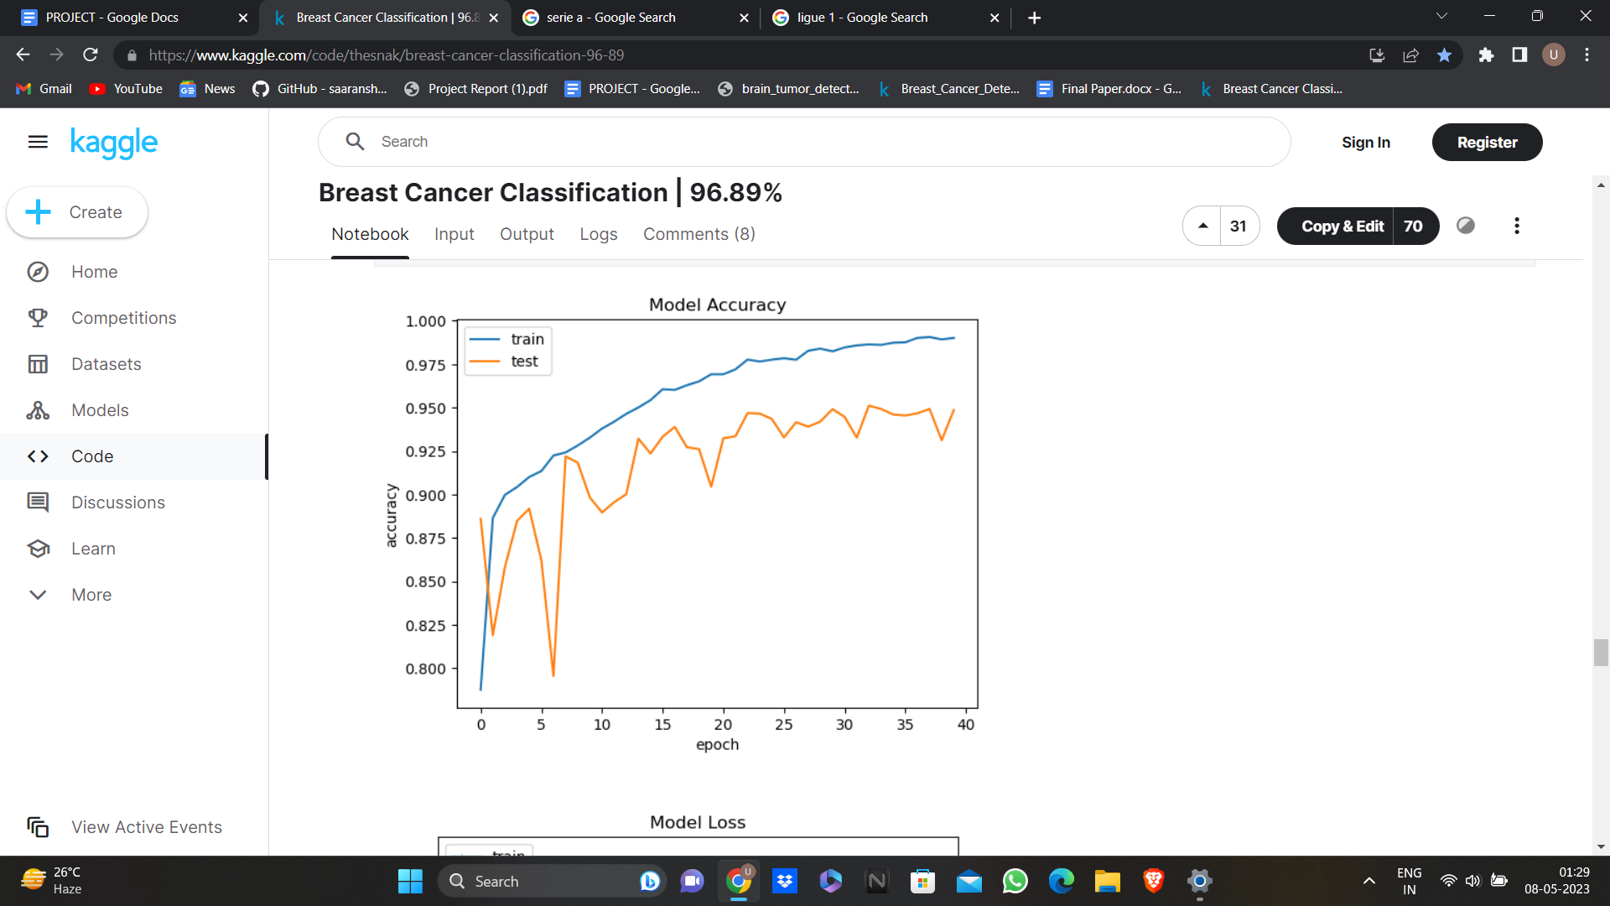

Fig. 4.3 Accuracy in training and validation

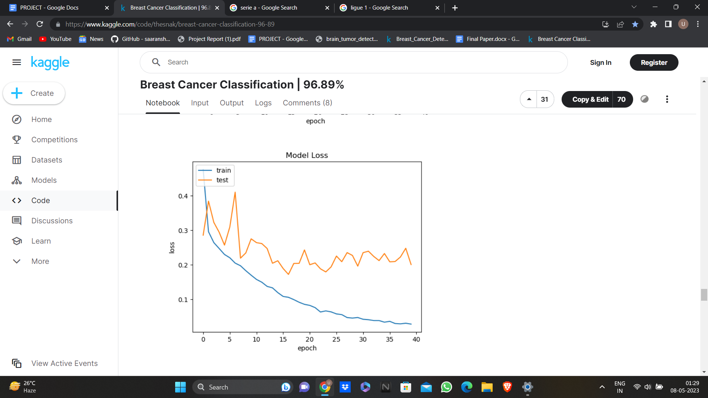

Fig. 4.4. Loss in training and validation

The graph represented in Fig. 4.3. displays the discrepancy in accuracy of validation and training data. The number of epochs is represented on x-axis while accuracy is measured on y-axis. According to the graph, the training accuracy attained is greater than the validation accuracy. The graph represented in Fig. 4.4. displays the discrepancy in loss of validation and training data. The number of epochs is represented on x-axis while loss is measured on y-axis. The training loss attained is lower than the validation loss as seen from the graph.

Table 4.1 Comparison of performance among previous proposed models

|  |  |  |  |  |
| --- | --- | --- | --- | --- |
| **Author** | **Year** | **Method** | **Accuracy** | **Remarks** |
| Romero et al. [22] | 2019 | CNN (Multi-level Batch normalization) | 89% | Composed of blocks derived from Inception that integrates batch normalization after each convolution step. |
| Proposed method | 2023 | CNN | 94.86% | A 22 -layer CNN model with Adam optimizer and binary cross entropy as loss function is proposed. |

# CHAPTER 5: CONCLUSION AND FUTURE WORK

**5.1 CONCLUSION**

The objective is to increase the pathologist's productivity by swiftly determining whether a sample of tissue is malignant or not by running it through the CNN model. The procedure can be made much more efficient by using the model because it can handle thousands of photos' worth of data in a matter of minutes, as opposed to days if it were done manually. In order to discriminate between each class and generate the best results, a CNN must extract characteristics from each image. The aforementioned report demonstrates that the model produces commendable outcomes. The CNN model architecture is being developed to automatically identify breast cancers. We evaluate our suggested model using a dataset of 277,524 patches.With a 40-epoch strategy, Our CNN model includes 22 layers. To reach our final result, we used 30% of the images as testing data and 70% of the images as training data. The proposed model has a 94.86% overall accuracy in detecting cancers from photos. The proposed approach may be seen as a computer-aided automated detection tool for precisely identifying breast abnormalities in histopathology data.The model might be enhanced. The model's output for current recall is adequate. The recall may be further enhanced for application in the actual world. Pathologists can find cancer on tissue more quickly thanks to this model. Examining tissue slides by hand would not be necessary.

# REFERENCES

[1] Hamidinekoo A, Denton E, Rampun A, Honnor K, Zwiggelaar R (2018) Deep learning in mammography and breast histology, an overview and future trends. Med Image Anal 47:45–67.

[2] M. Masud, A. E. Eldin Rashed, and M. S. Hossain, “Con-volutional neural network-based models for diagnosis of breast cancer,” Neural Computing and Applications, vol. 5, 2020.

[3] G. Muhammad, M. S. Hossain, and N. Kumar, “EEG-based pathology detection for home health monitoring,” IEEE Journal on Selected Areas in Communications, vol. 39, no. 2, pp. 603–610, 2021.

[4] Shahzad A, Usman AM, Muhammad S, Anam T, Khan Shoab A (2018) Decision support system for detection of hypertensive retinopathy using arteriovenous ratio. Artif Intell Med 90:15–24.

[5] Rajinikanth V, Satapathy SC, Fernandes SL, Nachiappan S (2017) Entropy based segmentation of tumor from ‘ mr images-a study with teaching learning based optimization. Pattern Recogn Lett 94:87–95.

[6] Fonseca P, Mendoza J, Wainer J, Ferrer J, Pinto J, Guerrero J, Castaneda B (2015) Automatic breast density classification using a convolutional neural network architecture search procedure. In: Medical imaging 2015: computer-aided diagnosis. International Society for Optics and Photonics, vol 9414, p 941428.

[7] Khan MA, Sharif M, Akram T, Yasmin M, Nayak RS (2019) Stomach deformities recognition using rank-based deep features selection. J Med Syst 43(12):329.

[8] Houssein EH, Emam MM, Ali AA, Suganthan PN (2020) Deep and machine learning techniques for medical imaging-based breast cancer: A comprehensive review. Expert Syst Appl 167:114161.

[9] Yap MH, Pons G, Martí J, Ganau S, Sentís M, Zwiggelaar R, Davison AK, Robert Martí (2017) Automated breast ultrasound lesions detection using convolutional neural networks. IEEE J Biomed Health Inform 22(4):1218–1226.

[10] Y. Wang, B. Lei, A. Elazab, E.-L. Tan, W. Wang, F. Huang, X. Gong and T. Wang, "Breast Cancer Image Classification via Multi-Network Features and DualNetwork Orthogonal Low-Rank Learning," IEEE Access, vol. 8, p. 27779–27792, 2020.

[11] Y. Li, J. Wu and Q. Wu, "Classification of breast cancer histology images using multi-size and discriminative patches based on deep learning," IEEE Access, vol. 7, p. 21400–21408, 2019.

[12] P. J. Sudharshan, C. Petitjean, F. Spanhol, L. E. Oliveira, L. Heutte and P. Honeine, "Multiple instance learning for histopathological breast cancer image classification," Expert Systems with Applications, vol. 117, p. 103–111, 2019.

[13] O. Maron and T. Lozano-Pérez, ‘‘A framework for multiple-instance learning,’’ in Proc. Adv. Neural Inf. Process. Syst., 1998, pp. 570–576.

[14] Q. Zhang and S. A. Goldman, ‘‘EM-DD: An improved multiple-instance learning technique,’’ in Proc. Adv. Neural Inf. Process. Syst., 2002, pp. 1073–1080.

[15] S. Andrews, I. Tsochantaridis, and T. Hofmann, ‘‘Support vector machines for multiple-instance learning,’’ in Proc. Adv. Neural Inf. Process. Syst., 2003, pp. 577–584.

[16] B. Babenko, P. Dollár, Z. Tu, and S. Belongie, ‘‘Simultaneous learning and alignment: Multi-instance and multi-pose learning,’’ in Proc. Workshop Faces Real-Life Images, Detection, Alignment, Recognit., 2008, pp. 1–15.

[17] K. Roy, D. Banik, D. Bhattacharjee and M. Nasipuri, "Patch-based system for Classification of Breast Histology images using deep learning," Computerized Medical Imaging and Graphics, vol. 71, p. 90–103, 2019.

[18] Z. Gandomkar, P. C. Brennan and C. Mello-Thoms, "MuDeRN: Multi-category classification of breast histopathological image using deep residual networks," Artificial intelligence in medicine, vol. 88, p. 14–24, 2018.

[19] D. Komura and S. Ishikawa, "Machine learning methods for histopathological image analysis," Computational and structural biotechnology journal, vol. 16, p. 34–42, 2018.

[20] D. M. Vo, N.-Q. Nguyen and S.-W. Lee, "Classification of breast cancer histology images using incremental boosting convolution networks," Information Sciences, vol. 482, p. 123–138, 2019.

[21] Mooney, P. (2017, December 19). Breast histopathology images. Kaggle. https://www.kaggle.com/datasets/paultimothymooney/breast-histopathology-images

[22] F. P. Romero, A. Tang and S. Kadoury, "Multi-Level Batch Normalization in Deep Networks for Invasive Ductal Carcinoma Cell Discrimination in Histopathology Images," 2019 IEEE 16th International Symposium on Biomedical Imaging (ISBI 2019), Venice, Italy, 2019, pp. 1092-1095, doi: 10.1109/ISBI.2019.8759410.

# 